MELFA SCARA RH-AH Robot RELEASE
Two models o f the RH SCARA robot range will be added to the Mitsubishi range of robots, namely:

Code SAP model name Description
a) 138033 RH-5AH55-S12 5kg payload SCARA robot 550mm reach
b) 142052 RH-10AH85-S12 10kg payload SCARA robot 850mm reach

These are to be available from Jan 2003 to approved Mitsubishi robot sales routes. Delivery Lead times expected to be around 12 weeks.

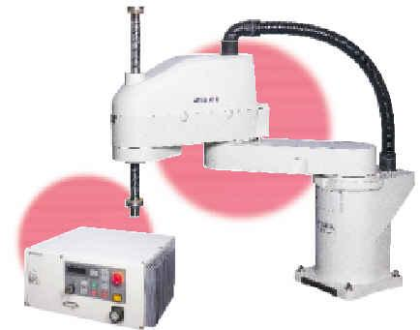

The RH-AH SCARA robot uses CR2A-572 controller and so will use the same MELFABASIC IV instructions as per other models of MELFA RV-A robot range. This controller will be used commonly for all the latest models of (RV-4A, RV-5AJ robots).

Key features of Mitsubishi RH-AH SCARA:
- Max Resultant speed of 5.3m/sec offers cycle times of only 0.48s
(25mm up and 300mm across and back)
- 64bit multi-tasking high performance CR2A controller
- High precision repeatability of +/-0.02mm
- Orthagonal Compliance “soft” arm capability.
- Easy “Direct mode” control with OCX development on PC as the host controller.
- Conveyor-tracking option module available
- Easy built-in RS422 and RS232C comms or expand with Ethernet or CCLINK to vision camera and other control devices.
- Built-in convenient 32digital inputs & 32 digital outputs.
- Easy SSCNET expansion to control further 8axes as base linear XY track or as XY linear track for work table.
- Convenient 240v AC single phase supply

Key points on Teach Pendant and programming software:
- R28TB teach pendant is compatible with all RV-A series including this SCARA range.
- COSIROP v1.7 onwards supports RH-5AH55, RH-10AH85 robots.
- COSIMIR version compatibility planned mid 2003.
- MELFAENG vC1 onwards supports RH-5AH, RH-10AH and other models of the SCARA range also.

Compatibility with other products:
The RH-AH SCARA range uses the CR2A roboto controller which will use the same option interfaces as the RV-A series of robots.

Further information :
- RH-AH brochure for a summary of specifications and options available (PDF file avail.)
- RH-5AH/10AH/15AH Series Standard Specifications Manual BFP-A8174-C (PDF avail.)

